RA-XF500A-WS
QR500 Coaxial Cable

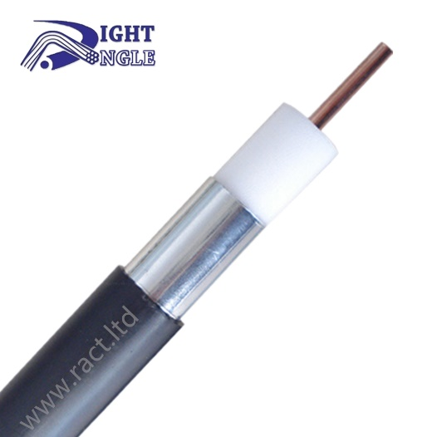

Product overview

QR500 cable aluminum tube cable refers to the physically foamed coaxial argon arc welding aluminum tube cable produced in the standard GY/T135-1998, which is widely used in satellite and television cables, including cable television, digital television, closed-circuit television, video transmission, security system and satellite television. Trunk cable, branch distribution cable.

Construction

Inner conductor | Material | CCA
Inner conductor | Diameter | 2.77 mm ± 0.02 mm
Insulation | Material | FPE
Insulation | Diameter | 11.43 mm ± 0.2 mm
Outer conductor | Material | SEAT
Outer conductor | Diameter | 12.70 mm ± 0.02 mm
Jacket | Material | PE
Jacket | Diameter | 14.20 mm ± 0.3 mm

Packing

Package length | 350m / 500m / 750m
Package length | Customized
Box type | Wooden drum
Box type | Customized

Test Data

Dielectric Strength | Not breakdown with 2kV DC for 1 min
Sheath Strength | Not breakdown with 3kV
Characteristic Resistance | 75 Ω ± 5 Ω
Insulation Resistance | 5000MΩ/km
Single Bending Radius | 70 mm
Repeated Bending Radius | 125 mm
Low Temperature Bending | Not cracked
Thermal Shock | Not cracked
Inner Conductor Resistance | ≤1.48 Ω/km
Velocity | 88 %

Certifications and Standards

Certification | CPR Eca
Executive Standards | GY/T135-1998

Technical Test [Attenuation @68°F(20°C)]

Frequency(MHZ) | Maximum(dB/100ft) | Maximum(dB/100m)
5 | 0.16 | 0.52
55 | 0.55 | 1.80
250 | 1.20 | 3.94
300 | 1.31 | 4.30
350 | 1.43 | 4.69
400 | 1.53 | 5.02
450 | 1.63 | 5.35
500 | 1.73 | 5.67
550 | 1.82 | 5.97
600 | 1.92 | 6.30
750 | 2.17 | 7.12
870 | 2.34 | 7.69
1000 | 2.53 | 8.30

